Ultrasonic sensor noise filtering

Owen Lu

Electroimpact Inc.

owenl@electroimpact.com

*Abstract*—This document describes the algorithm for filtering ultrasonic sensor reading spikes during real time operation. In the servo creel system, controller gain is scaled by the radius of the spool therefore, noise in this measurement can affect tension control, and reduction of noise increases the reliability of the system. A secondary function is to determine when the spool is running out of material via diameter measurement alone.

# Introduction

From the previous document “High level controller design” the controller gain which converts a dancer displacement error into an angular velocity command is calculated using a radius reading. A known problem using the ultrasonic sensor is that readings drop drastically during operation for short periods of time. The source of this effect is currently unknown. A steep drop in the radius instantaneously increases the proportional gain of the system, putting unnecessary strain on the motor possibly shortening motor life, and reducing system stability.

# Hardware remedies

During payout tests, it was observed that the ultrasonic sensor would at times read a very small radius for a short period of time. Generally, most of the jumps are eliminated by using a shielded cable, suggesting that the cause of the dips can be electrical as well. Brian L suggested that electrical noise from the DC servo motor could also be at play.

Typical radius reading signals during payout are shown below. The sinusoidal behavior is caused by wobble due to a worn coupling used during testing.

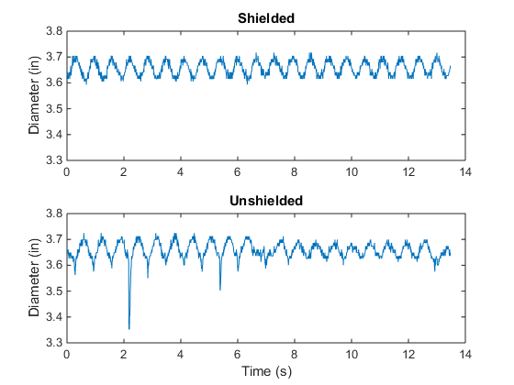

Figure - Shielded vs. Unshielded cable diameter readings

# Median filter

A median filter is a simple non-linear filter that is often used to remove outliers in a given signal. This is especially good in this case for eliminating short spikes in the ultrasonic signal. Much like a moving average filter, the median filter considers a moving set of neighboring data points, but instead calculates the median to be the output value. The key problem is to determine $n$ the number of points within the median filter calculation.

The results compared to the original data are shown for different window sizes.

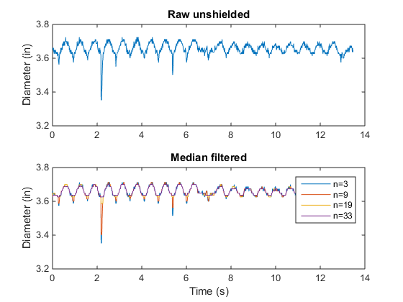

Figure - Unfiltered vs. Median filtered data for different window sizes

Empirically, a median filter of 19 points can reduce the spikes significantly. Further tests will be done on the shielded cable to verify the validity of the $n$ value.

# Moving average filter

A moving average filter can also be applied after the median filter. This is done in order to eliminate sinusoids due to wobble and mechanical imperfections in the spool itself that are periodic. In the test apparatus, wobble was significant, however, if the mechanical system is properly designed, the effect should be reduced naturally. Thus, it has not been determined whether a subsequent moving average filter is necessary in the final implementation, but the effects can be easily studied.

The key with calculation of window size is to find the fundamental period of the spool rotation so that the corresponding frequency and multiples of that frequency are eliminated from the measurement.

|  |  |  |
| --- | --- | --- |
|  |  | () |
|  |  | () |

Using the sampling rate given as $Δt$ we can calculate the window size of the moving average filter.

|  |  |  |
| --- | --- | --- |
|  |  | () |

Now applying the median filter and subsequent moving average filter we can compare the three signals.

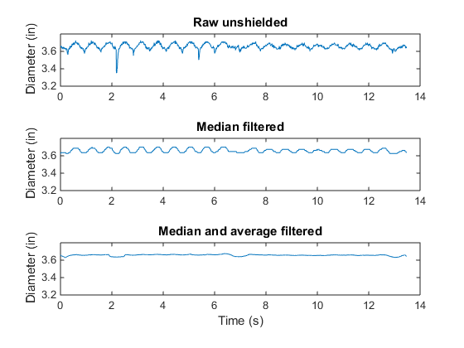

Figure - Comparison between raw, median, and median averaged signals

We can see that even the raw unshielded data can produce stable radius readings using the current algorithm.

# Long payout test

In order to see the hypothetical performance of the algorithm an extended test was done using a shielded cable. Payout was conducted at 2000in/min for more than one minute. Noticeably the spikes are present, but last for a shorter time than when using an unshielded cable shown in Figure 4.

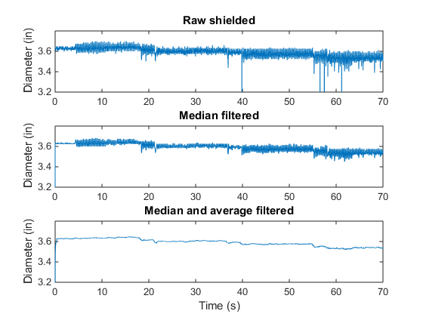

Figure - Extended test with shielded cable

Notably although these calculations are effective, it is possible that moving average and median filters are too computationally intensive to be performed on the SmartMotor in real time. Thus, raw data could be passed to the PLC and back to the motor in order to increase speed. This is a test that must be conducted when the PLC is integrated in the test bench.

# Low material detection

The main problem with detection low material is that the diameter readings must be extremely accurate near the diameter of the cardboard backing. This requires calibration, and unless a method can be developed that allows users to automatically calibrate the system before running, it is unlikely that the readings will be of sufficient accuracy.

However, after calibration it is very likely that radius signal can be used directly to trigger a stop condition as the 95% confidence interval of the measurement is less than 0.2mm. While the thickness of the carbon and backing has been measured to approximately 0.4mm. However, variation in the sensor placement and the cardboard backing uniformity may reduce the accuracy significantly.